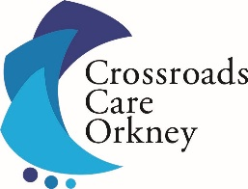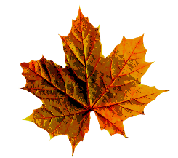
AUTUMN NEWSLETTER 2023
Dear Carer and Service User
Autumn is almost upon us again, apparently it doesn’t officially begin until 23rd September- but here in Orkney it happens when the shows are all past, or so Sheila just informed me!
This past quarter has seen us welcome our new Care Coordinator Steve Woods to the Crossroads team. He brings a wealth of knowledge and experience, and we were delighted when he joined us at the end of June.
The Blue Door Charity Shop
The Friends of Crossroads have a fundraising week in the Blue Door from Monday 18th September. If you are having a clear out any donations can be put to the Blue Door on the Friday or Saturday before this. Any donations of baking would also be most welcome.
Raffle Tickets
These are available in the office and the star prizes this year are a Lynnfield Lux Dinner with B&B for two and a NorthLink Travel Voucher for 4 passengers and a standard vehicle-Stromness to Scrabster return. There are many other amazing prizes and vouchers too from Sheila Fleet, William Shearer, Grooves Toys, K2, Hume Sweet Hume, Highland Park Distillery and many more. If you would like to sell raffle tickets please get in touch.
Cream Tea Afternoon
The Friends of Crossroads are holding the Annual Cream Tea on Saturday 4th of November from 2-4pm in the King Street Halls. The raffle will be drawn this day too. Any donations of raffle prizes, baking or bottles for our stalls on the day would be very welcome. If you are interested in joining the Friends of Crossroads to help them with their fundraising, please let the Office know.
Christmas Cards
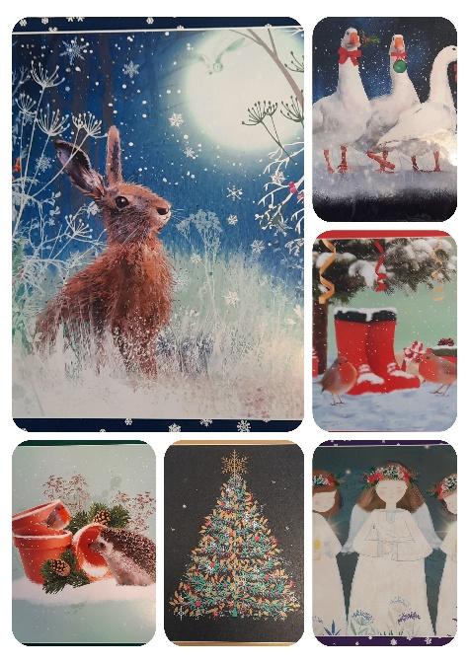
We now have Christmas Cards on sale in the office and they will also be on sale at the Tea afternoon. As always, there is a lovely selection to choose from. Larger cards are £4.00 per pack and smaller packs are £3.00.
Carers Support Group
This takes place on the second Wednesday of each month from 12-2pm. Keep an eye on our Facebook page or listen to Radio Orkney for updates. Bring a sandwich and we will provide tea, cake and a biscuit or three! The group is a chance to meet with other Carers have a chat and share information and ideas. Stay for the full 2 hours or pop in as you wish. If you are interested in attending this group or if there is anything specific you’d like to see happening, please do get in touch.

Time to Live Fund
This fund is for all Carers to help you have a short break. This is flexible because you can purchase anything that gives you a break such as a craft magazine subscription, music lessons, gym membership, garden bench, the list is endless. It doesn’t mean you need to jet off somewhere, although I’m sure the thought of that may appeal to us all! Please get in touch if you would like an application form for this fund.
NHS Orkney- Annual Review of Patient Experiences

Crossroads have been asked if we can help identify people with recent (within the last 12 months) experience of NHS treatment in Orkney. They are asking for individuals to participate in the patient group if they were willing and happy to provide feedback at a session towards the end of September. All reasonable expenses incurred will be reimbursed by NHS Orkney (NHSO) to ensure that the group is as inclusive as possible.

Laura Skaife-Knight, Chief Executive of NHSO, is keen that they have meaningful participation from patients from a range of backgrounds / experiences – positive and negative.
Please note that there will be no Scottish Government Ministers at this review – though there will be representatives from Scottish Government (either in person, or virtually).
Laura goes on to say they would like to give people early notice and to offer the opportunity to meet with them beforehand to outline what the session will involve, and to answer any questions they might have.

I would be very grateful if you can let me know as soon as possible if you would like to take part in this review and by Monday 18th September at the latest. It’s hugely important that NHSO learn from patient experiences and are able to take on board feedback and respond to it accordingly.
Please call 870500 or email carers@crossroadsorkney.co.uk to express your interest in the above.

Carers Parliament 2023

Every year Carers Scotland with the National Carer Organisations hold the Carers Parliament. This is an opportunity for Carers from across Scotland to hear directly from politicians and policymakers and tell them about their experiences and what needs to change. The Minister for Social Care and Mental Wellbeing Maree Todd and COSLA's spokesperson Councillor Paul Kelly will be amongst those in attendance.
There will also be an opportunity to discuss and influence policy affecting Carers, visit information standards and network with other Carers.
This year's event will be on 8 November at COSLA conference centre in Edinburgh and Carers can also attend online. Expenses including replacement care are available.
If you have any questions or would like further information, please do not hesitate to contact the office and we will pass on any queries to the Policies Officer at Carers Scotland.

Newsletter by Email

If you would like this newsletter emailed to you, please email carers@crossroadsorkney.co.uk stating you wish to receive an electronic copy.

Annual General Meeting

The Proposed date for the AGM is Tuesday 17th October 2023 at 5:30pm in the Office. This will be confirmed nearer the time. Please check the Orcadian, Radio Orkney and Crossroads Care Orkney Facebook page for updates on this. Enclosed is this year’s Annual Membership Form which is optional. Any queries don’t hesitate to contact us.

Health Improvement Scotland Survey

Please see the below flyer from Gerd Peters, Orkneys Engagement Officer. Please contact Gerd if you’d like to take part.
Healthcare Improvement Scotland – Community Engagement would like to talk to people who are living with a medical implanted device, capturing their views and experience to help shape policy and improve patient safety.
We are particularly interested in speaking to people who received a device from the list below within the last 5 years. Aiming to capture a broad range of experiences, we welcome people from all backgrounds and walks of life.

Heart valves | Joint replacements
Pacemakers | Lenses (cataract surgery)
Implantable defibrillators | Cochlear implants
Intravascular stents | Implantable stimulators
Aortic aneurysm stent grafts | Breast implants
Vascular and non-vascular stents | Gastric balloons

If you would like to find out more or would like to take part, please contact Gerd Peters, HIS Community Engagement in Orkney by emailing gerd.peters@nhs.scot

Please remember you can call us anytime- we are here to offer emotional support and advice and if we don’t know the answer, we will find someone who does.
Yours sincerely
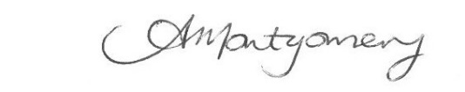

Orkney Carers Centre, West Castle Street, Kirkwall KW15 1GU TEL: 870500
Email: carers@crossroadsorkney.co.uk Registered Charity Number: SC022786. Co. No- 16342

